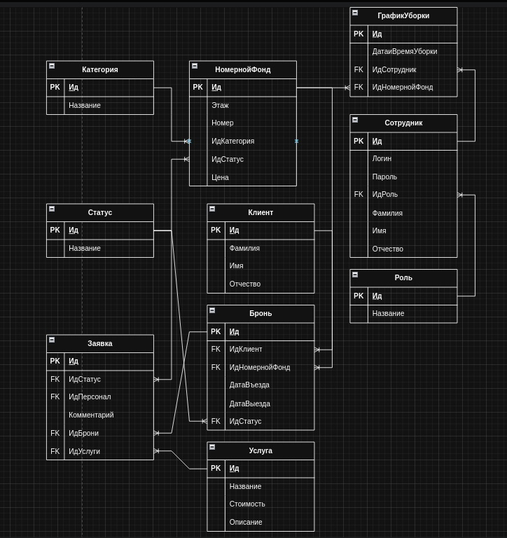

CREATE TABLE Category (

CategoryId SERIAL PRIMARY KEY,

Name VARCHAR(255) NOT NULL

);

CREATE TABLE Status (

StatusId SERIAL PRIMARY KEY,

Name VARCHAR(255) NOT NULL

);

CREATE TABLE RoomFund (

RoomFundId SERIAL PRIMARY KEY,

Floor INTEGER NOT NULL,

RoomNumber VARCHAR(50) NOT NULL,

CategoryId INTEGER REFERENCES Category(CategoryId),

StatusId INTEGER REFERENCES Status(StatusId),

Price NUMERIC(10, 2) NOT NULL

);

CREATE TABLE Client (

ClientId SERIAL PRIMARY KEY,

LastName VARCHAR(255) NOT NULL,

FirstName VARCHAR(255) NOT NULL,

MiddleName VARCHAR(255)

);

CREATE TABLE Role (

RoleId SERIAL PRIMARY KEY,

Name VARCHAR(255) NOT NULL

);

CREATE TABLE Employee (

EmployeeId SERIAL PRIMARY KEY,

Login VARCHAR(255) NOT NULL UNIQUE,

PasswordHash VARCHAR(255) NOT NULL,

RoleId INTEGER REFERENCES Role(RoleId),

LastName VARCHAR(255) NOT NULL,

FirstName VARCHAR(255) NOT NULL,

MiddleName VARCHAR(255)

);

CREATE TABLE CleaningSchedule (

CleaningScheduleId SERIAL PRIMARY KEY,

CleaningDate TIMESTAMP NOT NULL,

EmployeeId INTEGER REFERENCES Employee(EmployeeId),

RoomFundId INTEGER REFERENCES RoomFund(RoomFundId)

);

CREATE TABLE Service (

ServiceId SERIAL PRIMARY KEY,

Name VARCHAR(255) NOT NULL,

Cost NUMERIC(10, 2) NOT NULL,

Description TEXT

);

CREATE TABLE Booking (

BookingId SERIAL PRIMARY KEY,

ClientId INTEGER REFERENCES Client(ClientId),

RoomFundId INTEGER REFERENCES RoomFund(RoomFundId),

CheckInDate DATE NOT NULL,

CheckOutDate DATE NOT NULL,

StatusId INTEGER REFERENCES Status(StatusId)

);

CREATE TABLE Request (

RequestId SERIAL PRIMARY KEY,

StatusId INTEGER REFERENCES Status(StatusId),

EmployeeId INTEGER REFERENCES Employee(EmployeeId),

Comment TEXT,

BookingId INTEGER REFERENCES Booking(BookingId),

ServiceId INTEGER REFERENCES Service(ServiceId)

);